**Laptops Don't Belong in Classrooms for Now**

In an era where digital tools are ubiquitous, the question of whether laptops should be allowed in college classrooms is contentious. Proponents argue that laptops facilitate learning, offering students the ability to search for related materials and take notes more quickly. However, there are compelling arguments suggesting that the disadvantages of laptop usage in class actually outweigh the benefits.

The primary concern about allowing laptops in the classroom is the significant off-task distraction they pose. The potential for distraction from a laptop is so high that students often succumb to off-task activities, despite intending to use their laptops only for class-related purposes, such as taking notes and viewing slides. Social media, streaming videos, and games are just a click away, making it difficult for even the most disciplined students to remain focused. These constant distractions can severely diminish a student's ability to concentrate on the lecture, leading to poorer comprehension and retention of course material. Research indicates that higher rates of internet use in classroom are associated with lower test grades, and students' beliefs about this relationship do not reflect their ability to multitask effectively (Ravizza, Hambrick, & Fenn, 2014). Students tend to underestimate the time they spend off-task and the effect it has. A study on notification alerts reported that it took participants 8–9 minutes to return to their primary task after email and instant messaging interruptions, even though they intended to get back on task as quickly as possible (Iqbal & Horvitz, 2007).

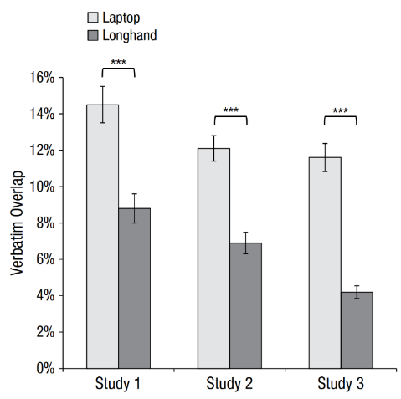Even when the computer is used for its intended function of easier note-taking, it does more harm than good. It seems intuitive that taking notes on a laptop would be more efficient than taking notes on paper because typing is faster than handwriting. As such, one might assume that learning would be enhanced when students take notes on laptops because they can record their notes fast, freeing up time to listen and engage with the lecture on a deeper level. However, prior research (Mueller & Oppenheimer, 2014) has shown in Figure 1 that longhand notes involve less verbatim overlap. This means when students take notes on a laptop, they tend to transcribe verbatim phrases directly from the lecture rather than processing information and restructuring it in their own words. This superficial engagement with the material results in a less effective learning process, where the depth of understanding is compromised for the sake of note-taking speed.

Figure 1

Moreover, the use of laptops affects not only individual students but also the classroom dynamic, which distracts the whole class. A laptop screen can create a barrier between the student and the instructor, inhibiting important visual cues that improve understanding. In discussions, students who are behind screens might participate less and may be perceived as less approachable by their peers and teachers. This can degrade the quality of in-class discussions, which are vital for learning proactively and developing oral communication skills, especially for English classes.

While laptops are undoubtedly effective tools in carefully designed classes (Flipped Classroom), their benefits in regular classroom settings are overshadowed by the risks of distraction. The goal of education is not merely to provide information but to foster a deep, meaningful understanding and develop critical thinking and active learning capabilities. Until we can find effective strategies to mitigate negative impacts, banning laptops from the classroom for now may be a wiser choice.(567 words)

**References**

Iqbal, S. T., & Horvitz, E. (2007). Disruption and recovery of computing tasks: Field study, analysis, and directions. In *Proceedings of the SIGCHI Conference on Human Factors in Computing Systems* (pp. 677–686).

Mueller, P. A., & Oppenheimer, D. M. (2014). The pen is mightier than the keyboard: Advantages of longhand over laptop note taking. *Psychological Science, 25*(6), 1159-1168.

Ravizza, S. M., Hambrick, D. Z., & Fenn, K. M. (2014). Non-academic internet use in the classroom is negatively related to classroom learning regardless of intellectual ability. *Computers & Education,* 78, 109-114.